­./

GENESIS - Learning Outcome & Mini-project Summary Report



|  |  |  |  |  |  |
| --- | --- | --- | --- | --- | --- |
| **Ver. Rel. No.** | **Release Date** | **Prepared. By** | **Reviewed By** | **To be Approved** | **Remarks/Revision Details** |
| 1. | 11-Nov-2020 | Harshavardhan C.A (99002634)  Srikar Reddy B. (99002586)  Smita Senapati (99002489) |  |  |  |

**Details**

# Table of Contents

Table of Contents 3

**List of Figures** 4

**List of Tables** 5

Miniproject -1 [Team] 6

Module: JavaScript and Jasmine Framework, and SDLC 6

Topic and Subtopics 6

Design of a Bank Web page: 6

Jasmine Framework Unit Testing 6

Selenium Automation Testing 6

Objectives & Requirements 6

Objectives 6

High level Requirements 6

Low Level Requirements 6

Design 8

Behavioral Diagrams 8

Structural Diagrams 9

Test Plan 9

Implementation Summary 12

Video Summary 12

GitHub Link 12

GitHub Dashboard 13

Summary 13

Individual Contribution & Highlights 16

Challenges faced and how were they overcome 16

## **List of Figures**

Figure 1: User Case Diagram 8

Figure 2: Object Diagram 9

Figure 3: GitHub Dashboard 13

Figure 4: Code Quality Badge 13

Figure 5: Jasmine Framework Unit Testing Results 15

## **List of Tables**

Table 1: Test Plan 12

# Miniproject -1 [Team]

# Module: JavaScript and Jasmine Framework, and SDLC

## Topic and Subtopics

### Design of a Bank Web page:

* For designing the webpage, we have used HTML and CSS language to provide structure and style to our web page
* In this java script is being used to make the web page more interactive.

### Jasmine Framework Unit Testing

* We had implemented Jasmine framework to test our JavaScript application.

### Selenium Automation Testing

* we had automated our web page using selenium.

## Objectives & Requirements

### Objectives

Our Objective is to create a Web page for a bank which consists of the following requirements:

### High level Requirements

H1 - Home Page

H2 – Banking

H3 – Loans

H4 - Online Services

H5 - Terms and Conditions

H6 - First Time User

H7 – Login

### Low Level Requirements

1. H1 - Home Page:

The homepage consists of login option and other information about banking, loan, help and services.

1. H2 - Banking:

This includes various low level requirements as follows:

L1-online banking

* L1_1- My Accounts
* L1_2- My Transactions
* L1_3- Net Banking
* L1_4- Online Offers
* L1_5- Mobile Banking

L2-services

* L2_1-Statement on Email
* L2_2-Online Services

L3-Other useful links

* L3_1-FATCA and CRS
* L3_2-Interest Rate
* L3_3-Terms and conditions

1. H3 - Loans

L1-Online Loans

* L1_1-Personal Loan
* L1_2-Apply for Loan on Credit Card
* L1_3-Home Loan
* L1_4-Business Loan

L2-Useful links

* L2_1-FATCA and CRS
* L2_2-Interest Rate
* L2_3-Terms and conditions

1. H4 - Online Services

L1-Net Banking

* L1_1-login

L2-Mobile banking

* L2_1-Learn More

L3-Online Transactions

* L3_1-Go online

L4-Statement on Email

* L4_1-Check now

1. H5 - Terms and Conditions

L1-FATCA and CRSN

L2-Interest Rate

L3-T&C

6) H6 - First Time User

7) H7 – Login

## Design

### Behavioral Diagrams

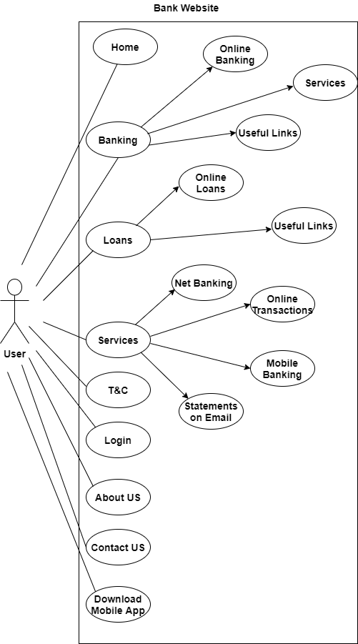

Figure 1: User Case Diagram

### Structural Diagrams

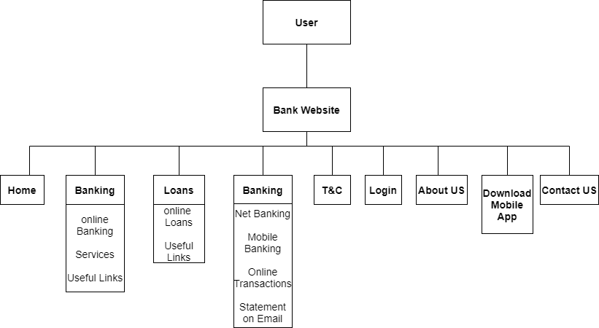

Figure 2: Object Diagram

## Test Plan

|  |  |  |  |  |
| --- | --- | --- | --- | --- |
| **Test ID** | **Test Description** | **Input** | **Expected Output** | **Result** |
| H1 | To test the Home option on the homepage | Click on the option | It should show redirect the user to the homepage | Pass |
| H2 | To test the Banking option on the homepage | Click on the option | It should redirect the user to the banking page | Pass |
| H3 | To test the Loans option on the homepage | Click on the option | It should redirect the user to the loans page | Pass |
| H4 | To test the Services option on the homepage | Click on the option | It should redirect the user to the services page | Pass |
| H5 | To test the T&C option on the homepage | Click on the option | It should redirect the user to the T&C page | Pass |
| H6 | To test the register option on the homepage | Click on the option | It should redirect the user to the registration page | Pass |
| H7 | To test the forgot password option on the homepage | Click on the option | It should redirect the user to the forgot password page | Pass |
| H2_L1 | To test the customer ID field in the My Account page | Enter the customer ID | It should take in the customer ID if it’s in the right format or shows an error | Pass |
| H2_L2 | To test the password/PIN field in the My Account page | Enter the password/PIN | The password/PIN should be given in the correct format or an error is thrown | Pass |
| H2_L3 | To test the customer ID field in the My Transactions page | Enter the customer ID | It should take in the customer ID if it’s in the right format or shows an error | Pass |
| H2_L4 | To test the password/PIN field in the My Transactions page | Enter the password/PIN | The password/PIN should be given in the correct format or an error is thrown | Pass |
| H2_L5 | To test the customer ID field in the Net Banking page | Enter the customer ID | It should take in the customer ID if it’s in the right format or shows an error | Pass |
| H2_L6 | To test the Credit Card/Debit Card radio buttons in the Net Banking page | Select an option from the two radio buttons | Selected button(Credit/Debit Card) | Pass |
| H2_L7 | To test the valid through field in the Net Banking page | Enter the expiry date | It should take in the expiry date if it’s in the right format or shows an error | Pass |
| H2_L8 | To test the password/PIN field in the Net Banking page | Enter the password/PIN | The password/PIN should be given in the correct format or an error is thrown | Pass |
| H2_L9 | To test the customer ID field in the Statement on email page | Enter the customer ID | It should take in the customer ID if it’s in the right format or shows an error | Pass |
| H2_L10 | To test the e-mail address field in the Statement on email page | Enter the email address | It should take in a valid email address or shows an error | Pass |
| H2_L11 | To test the password/PIN field in the Statement on email page | Enter the password/PIN | The password/PIN should be given in the correct format or an error is thrown | Pass |
| H3_L1 | To test the full name field in the Personal loan page | Enter the full name | The full name should be given in the correct format or an error is thrown | Pass |
| H3_L2 | To test the email address field in the Personal loan page | Enter the email address | The email address should be given in the correct format or an error is thrown | Pass |
| H3_L3 | To test the Phone No. field in the Personal loan page | Enter the phone no | The phone no. should be given in the correct format or an error is thrown | Pass |
| H3_L4 | To test the gender radio buttons in the Personal loan page | Select an option from the two radio buttons | Selected button(Male/Female) | Pass |
| H3_L5 | To test the Account No. field in the Personal loan page | Enter the bank account no. | The bank account no. should be given in the correct format or an error is thrown | Pass |
| H3_L6 | To test the IFSC code field in the Personal loan page | Enter the IFSC code | The IFSC code should be given in the correct format or an error is thrown | Pass |
| H3_L7 | To test the Branch field in the Personal loan page | Enter the branch | The branch should be given in the correct format or an error is thrown | Pass |
| H3_L8 | To test the Name field in the Apply for Loan on Credit Card page | Enter the name | The name should be given in the correct format or an error is thrown | Pass |
| H3_L9 | To test the Phone No. in the Apply for Loan on Credit Card page | Enter the Phone No. | The Phone No. should be given in the correct format or an error is thrown | Pass |
| H3_L10 | To test the Credit Card No. in the Apply for Loan on Credit Card page | Enter the Credit Card No. | The name should be given in the correct format or an error is thrown | Pass |
| H3_L11 | To test the Password/PIN field the Apply for Loan on Credit Card page | Enter the Password/PIN | The password/PIN should be given in the correct format or an error is thrown | Pass |
| H3_L12 | To test the name field in the Home loan page | Enter the name | The name should be given in the correct format or an error is thrown | Pass |
| H3_L13 | To test the Phone No. field in the Home loan page | Enter the Phone No. | The Phone No. should be given in the correct format or an error is thrown | Pass |
| H3_L14 | To test the address field in the Home loan page | Enter the address | The address should be given in the correct format or an error is thrown | Pass |
| H3_L15 | To test the gender radio buttons in the Personal loan page | Select an option from the two radio buttons | Selected button(Male/Female) | Pass |
| H3_L16 | To test the branch field in the Home loan page | Enter the branch | The branch should be given in the correct format or an error is thrown | Pass |
| H3_L17 | To test the amount field in the Home loan page | Enter the amount | Valid amount should be given or an error is thrown | Pass |
| H3_L18 | To test the Loan Tenure field in the Home loan page | Enter the Loan Tenure | Valid Loan Tenure should be given or an error is thrown | Pass |
| H3_L19 | To test the Name field in the Business loan application page | Enter the Name | Valid name should be given or an error is thrown | Pass |
| H3_L20 | To test the Phone No. field in the Business loan application page | Enter the Phone No. | The Phone No. should be given in the correct format or an error is thrown | Pass |
| H3_L21 | To test the address field in the Business loan application page | Enter the address | The address should be given in the correct format or an error is thrown | Pass |
| H3_L22 | To test the gender radio buttons in the Business loan application page | Select an option from the two radio buttons | Selected button(Male/Female) | Pass |
| H3_L23 | To test the branch field in the Business loan application page | Enter the branch | The branch should be given in the correct format or an error is thrown | Pass |
| H3_L24 | To test the amount field in the Business loan application page | Enter the amount | Valid amount should be given or an error is thrown | Pass |
| H3_L25 | To test the Loan Tenure field in Business loan application page | Enter the Loan Tenure | Valid Loan Tenure should be given or an error is thrown | Pass |

Table 1: Test Plan

## Implementation Summary

* Here we have implemented HTML and CSS language to give a structure and style to the webpage.
* Using JavaScript, we have made our web page more interactive and dynamic in nature and have made our web page more functional.
* We have implemented the Jasmine framework here to test our JavaScript application.
* Lastly we have automated the webpage by using selenium.

### Video Summary

<https://github.com/99002634/2009MYSEMB03-JavaScript-1/blob/main/JavaScript_miniproject/6_ImagesandVideos/GENESIS%20-2009MYSEMB03-%20JavaScriptMini%20Project.rar>

### GitHub Link

<https://github.com/99002634/2009MYSEMB03-JavaScript-1>

### GitHub Dashboard

The below screenshot shows the GitHub Dashboard of the JavaScript mini-project.

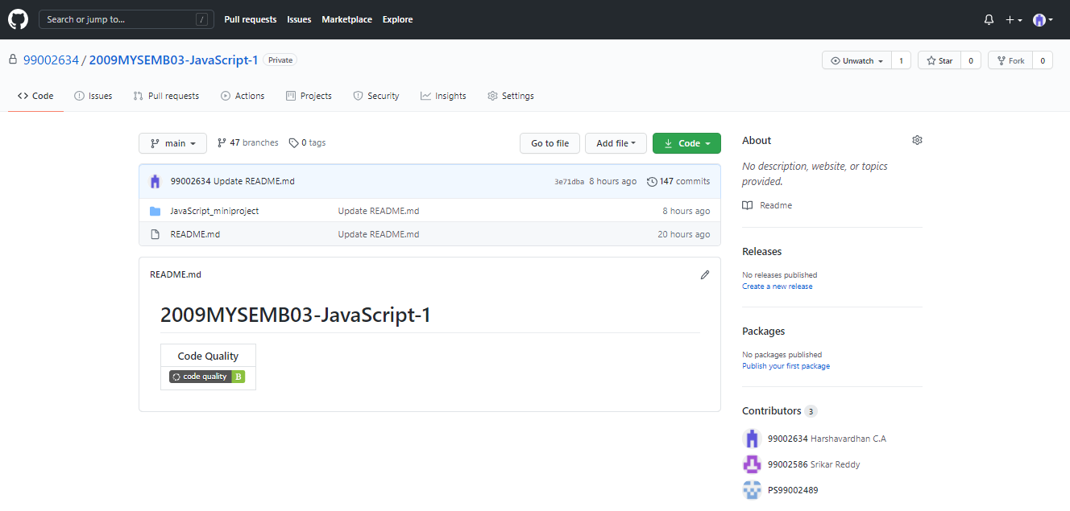

Figure 3: GitHub Dashboard

### Summary

#### Code quality and Issues or Bug Tracking

The below screenshot shows the code quality of the JavaScript mini-project.

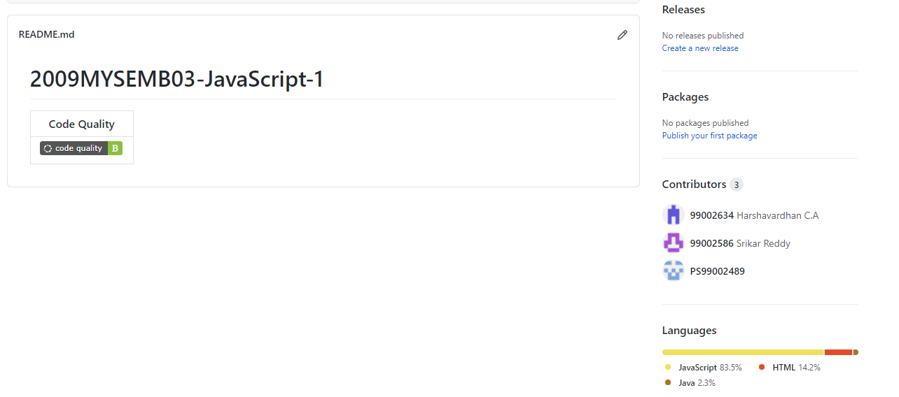

Figure 4: Code Quality Badge

**Bug Tracking**

1. Initially the “Login Now” button on the homepage was redirecting to the wrong webpage, but the problem is solved.
2. Unable to automate the login page because of wrong login credentials.

#### Unit Testing

These are the unit tests for every functionality:

* Testing the Business Loan Application
  + Check for Full Name
  + Check for Phone No.
  + Check for Address
  + Check for Branch
  + Check for Business Name
  + Check for Amount
  + Check for Loan Tenure
* Testing the Create Account
  + Check for First Name
  + Check for Last Name
  + Check for Phone No.
  + Check for E-mail Address
  + Check for Address
  + Check for Password
  + Check for Confirm Password
* Testing the Forgot Password
  + Check for Customer ID
  + Check for E-mail Address
* Testing the Home Loan
  + Check for Name
  + Check for Phone No.
  + Check for Address
  + Check for Branch
  + Check for Amount
  + Check for Loan Tenure
* Testing the Apply for Loan on Credit Card
  + Check for Name
  + Check for Phone No.
  + Check for Credit Card No.
  + Check for PIN
  + Check for Password
* Testing the Account Login
  + Check for Customer ID
  + Check for PIN
  + Check for Password
* Testing the To check Transaction Details
  + Check for Customer ID
  + Check for PIN
  + Check for Password
* Testing the Net Banking
  + Check for Customer ID
  + Check for Valid Through
  + Check for Password
  + Check for PIN
* Testing the Personal Loan Application form
  + Check for Full Name
  + Check for E-mail Address
  + Check for Phone No.
  + Check for Account No.
  + Check for IFSC
  + Check for Branch
* Testing the Statement on E-mail
  + Check for Customer ID
  + Check for E-mail Address
  + Check for Password
  + Check for PIN

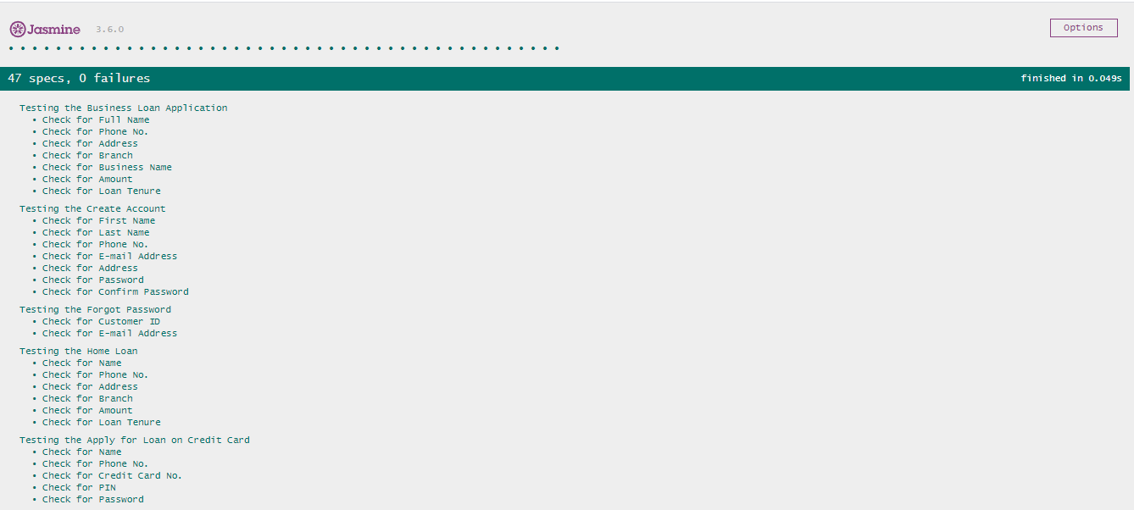

Figure 5: Jasmine Framework Unit Testing Results

## Individual Contribution & Highlights

**99002634 (Harshavardhan C.A):**

1. Created AboutUS.html file
2. Created Home.html file
3. Created Loans.html file
4. Created MyTransactions.html file
5. Created OnlineOffers.html file
6. Created StatementsOnEmail.html file
7. Created UsefulLinks.html file
8. Created BankwebsiteSpec.js file
9. Created Bankwebsite.js file

**99002586 (B. Srikar Reddy):**

1. Created FirstTimeUser.html file
2. Created LoanonCreditCard.html file
3. Created MyAccount.html file
4. Created Functions.js file
5. Created NetBanking.html file
6. Created OnlineServices.html file

**99002489 (Smita Senapati):**

1. Created BusinessLoan.html file
2. Created ForgotPassword.html file
3. Created HomeLoan.html file
4. Created MobileBanking.html file
5. Created PersonalLoans.html file

## Challenges faced and how were they overcome

We are Unable to build the JavaScript file because we didn’t have the JSON file in our project.

### 